JOB PORTAL SYSTEM

SUBMITTED BY

MANU JACOB

**Table Of Contents**

**1. Introduction**

1.1 Purpose

1.2 Scope

1.3 Objectives

**2. Functional Requirements**

2.1 Primary Actors of The System

2.2 Use Case Diagram

2.2.1 Job Seeker

2.2.2 Job Provider

2.2.3 Platform Admin

2.3 User Stories

2.3.1 Job Seeker

2.3.2 Job Provider

2.3.2 Platform Admin

2.4 Business Process Diagram

**3. Non-Functional Requirements**

**4. Technical Requirements**

**5. Conclusion**

**1. Introduction**

The Job Portal System is an online platform designed to bridge the gap between **job seekers** and **job providers** by offering a centralized and user-friendly environment for recruitment activities. The system enables job seekers to create and manage professional profiles, upload resumes, search for relevant job opportunities, and apply directly to employers. On the other hand, job providers can post job openings, manage applications, shortlist candidates, and communicate with potential employees efficiently. The platform also includes an **administrative module**, where platform admins monitor and manage the overall system to ensure security, authenticity, and smooth operation. By digitizing and streamlining the hiring process, the Job Portal System reduces time, cost, and effort for both candidates and employers.

**1.1 Purpose**

* To provide job seekers with a platform to **create professional profiles**, **upload resumes**, and **apply for suitable jobs**.
* To enable employers to **post job openings**, **search for candidates**, and **manage applications** effectively.
* To support platform admins in **maintaining system integrity**, ensuring that only legitimate job postings and genuine candidate profiles are available.
* To improve the overall **recruitment process efficiency** by reducing hiring time and improving candidate–job matching.

**1.2 Scope**

The Job Portal System is designed to serve as a comprehensive recruitment platform that brings together job seekers, employers, and administrators in a single, integrated environment. Its scope includes all major functionalities required for the end-to-end recruitment process, from job posting and application submission to hiring and administration. It is primary focus will be on simplifying job search and recruitment, while offering transparency, convenience, and efficiency to all stakeholders.

**1.3 Objectives**

The main objectives of a job portal system are to facilitate communication and interaction between job seekers and employers, provide a centralized platform for job searching and recruitment, and streamline the entire process by automating manual tasks to improve efficiency and accessibility. Key goals include enabling job seekers to find relevant opportunities and post resumes, allowing employers to advertise positions and search for candidates, and offering features like application tracking, job alerts, and user profiles to enhance the user experience for both parties.

**2. Functional Requirements**

**2.1 Primary Actors**

* **Job Provider** - posts jobs, reviews applicants.
* **Job Seeker** - creates profiles, searches jobs, applies for jobs.
* **Platform Admin** - manages the platform, moderates jobs, oversees

**2.2 Use Case Diagram**

It is the visual representation of how actors interact with the system. Creating a use case diagram for an online job portal provides several benefits to **platform admin, job seekers,** and **job providers**.

Firstly, it helps developers to understand the interactions that take place between users and the different components of the system. By identifying the key features of the platform, developers can ensure that each feature is designed to function seamlessly, providing a smooth and efficient experience for both job seekers and employers. This understanding is essential for ensuring that the job portal meets the needs of its users effectively and provides a high-quality service.

Secondly, a use case diagram helps to identify potential issues or bottlenecks in the system, allowing developers and employers to address these issues before they become problematic. For example, if the diagram reveals that the job search engine is not returning accurate results, it may be necessary to adjust the search parameters to ensure that job seekers can find relevant job opportunities quickly and easily.

**2.2.1 Job Seeker**

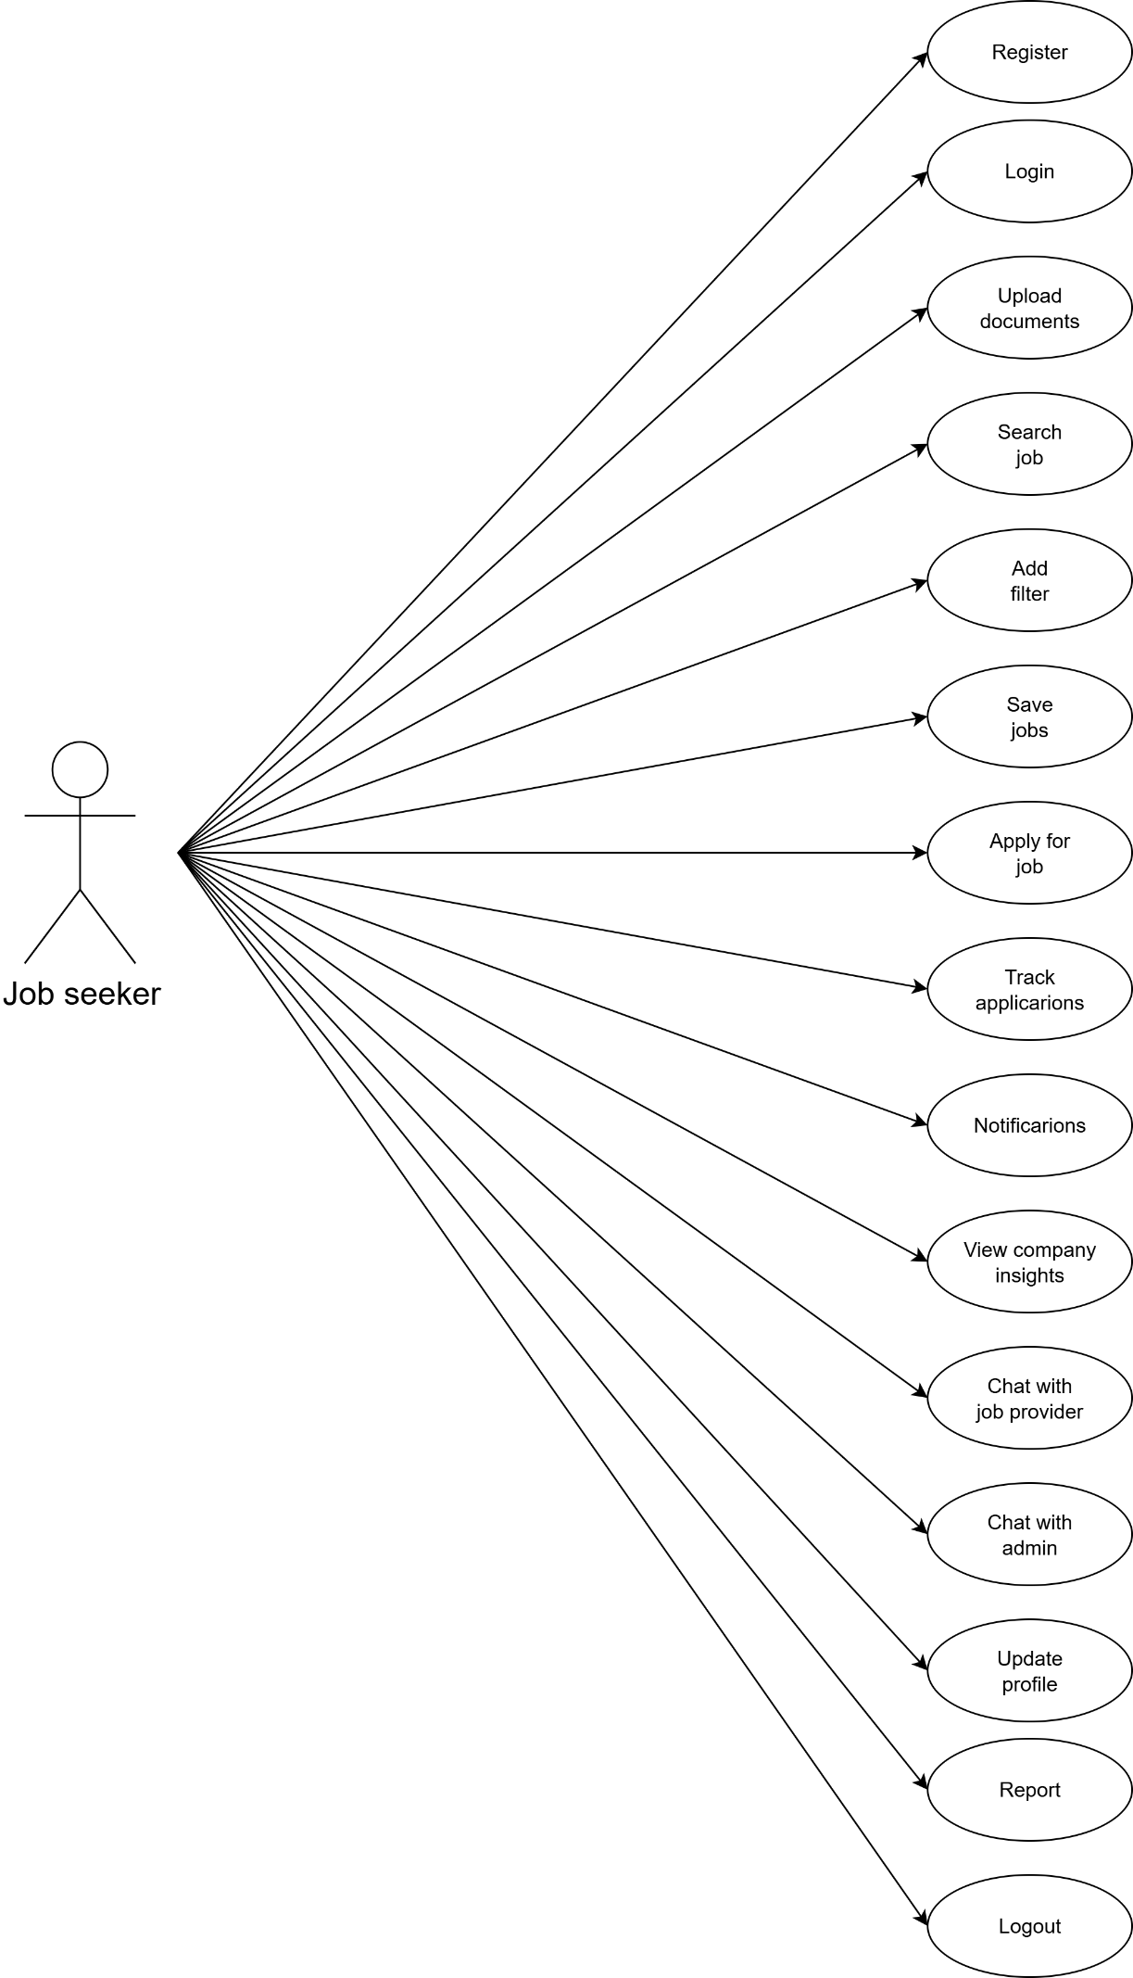

**2.2.2 Job Provider**

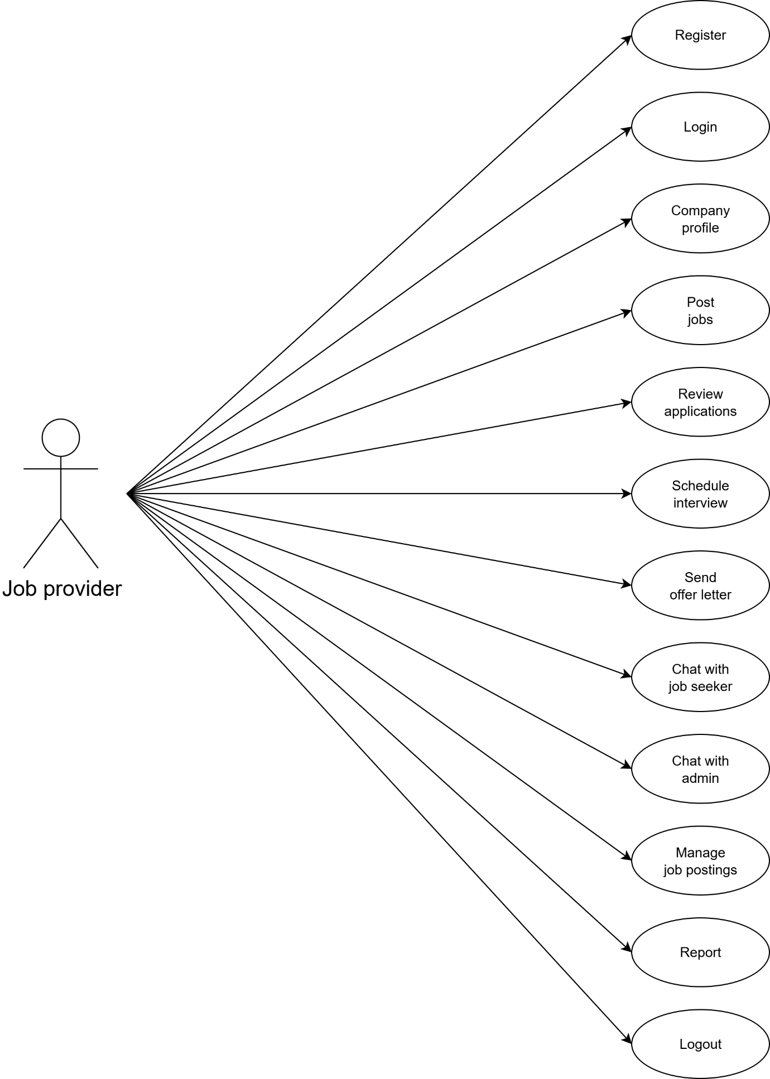

**2.2.3 Platform Admin**

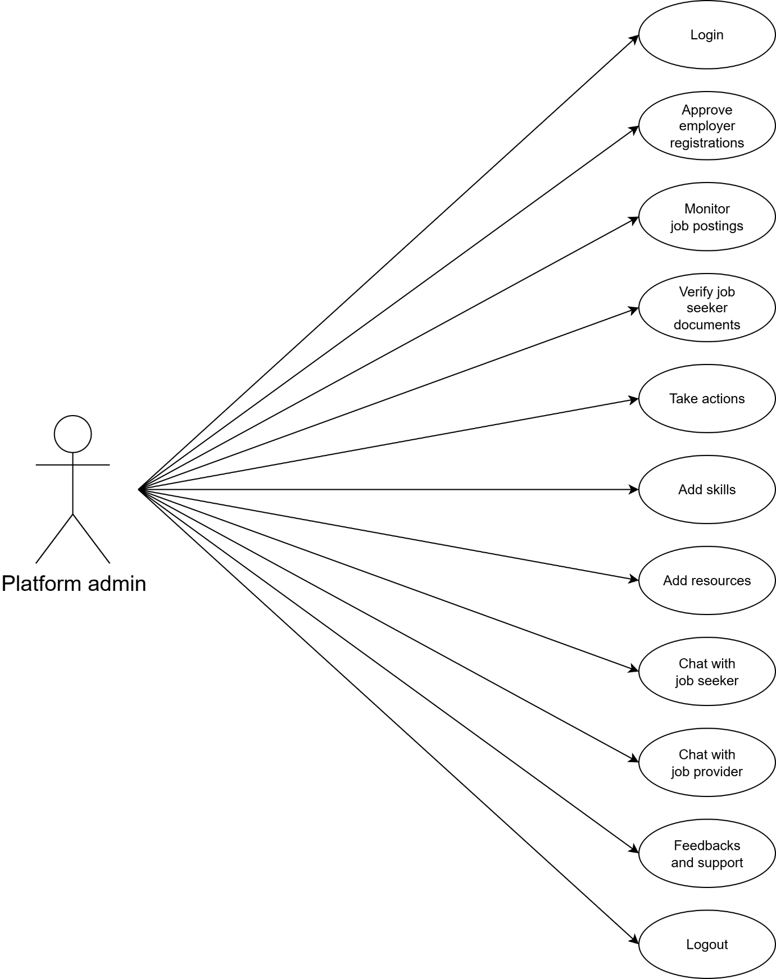

**2.3 User Stories**

User stories for a job portal system define features from the end-user's perspective.

**2.3.1 Job Seeker**

|  |  |  |
| --- | --- | --- |
| AS A  [type of user] | I NEED TO  [do some task] | SO THAT I CAN  [get some result] |
| Job seeker | Register | Add my name and details so that employers can find me |
| Job seeker | Login | Access my profile |
| Job seeker | Upload documents | Upload my resume |
| Job seeker | Search job | Search and find the jobs that I can apply |
| Job Seeker | Add filter | Search jobs according to my preference |
| Job seeker | Save jobs | Save jobs to wish list so I can quickly find and apply for the job later |
| Job seeker | Apply for job | Apply for the jobs of multiple companies |
| Job seeker | Track applications | Check the status of the applied jobs |
| Job seeker | Notifications | I can stay updated |
| Job seeker | View company insights | Evaluate job providers and positions available |
| Job seeker | Chat with job provider | Chat with job provider for enquiries about job and interviews |
| Job seeker | Chat with admin | Chat with admin for enquiries and further assistant |
| Job seeker | Update profile | Keep my profile updated |
| Job seeker | Report | Report violations against job provider |
| Job seeker | Logout | Logout from the account |

**2.3.2 Job Provider**

|  |  |  |
| --- | --- | --- |
| Job provider | Register | Add company details |
| Job provider | Login | Login to the account |
| Job provider | Company profile | Create company profile and details |
| Job provider | Post jobs | Find candidates for the jobs |
| Job provider | Review applications | Shortlist suitable candidates |
| Job provider | Schedule interview | Send interview notification to selected candidates |
| Job provider | Send offer letter | Make hiring process smoother |
| Job provider | Chat with job seeker | For further enquiries |
| Job provider | Chat with admin | For help and support |
| Job provider | Manage job postings | Edit and update the job postings |
| Job provider | Report | Report violations against job seeker |
| Job provider | Logout | Logout from the account |

**2.3.3 Platform Admin**

|  |  |  |
| --- | --- | --- |
| Platform admin | Login | Access admin page |
| Platform admin | Approve employer registrations | Only verified companies can post the jobs |
| Platform admin | Monitor job postings | Remove fraud or spam job postings |
| Platform admin | Verify job seeker documents | Flag fake or inappropriate profiles |
| Platform admin | Take actions | Take actions against violations from users |
| Platform admin | Add skills | Add required job skills for listings or job profiles |
| Platform admin | Add resources | Enhance user experience by adding tools like resume templates, career advice articles…..etc |
| Platform admin | Chat with job seeker | For support and assistance |
| Platform admin | Chat with job provider | For support and assistance |
| Platform admin | Feedbacks and support | Improve the service quality |
| Platform admin | Logout | Logout from the admin page |

**2.4 Business Process Diagram**

A business process diagram (BPD) for a job portal system visually maps the workflows for job seekers and employers, showing processes like registration, job posting, application submission, resume search, and interview scheduling.

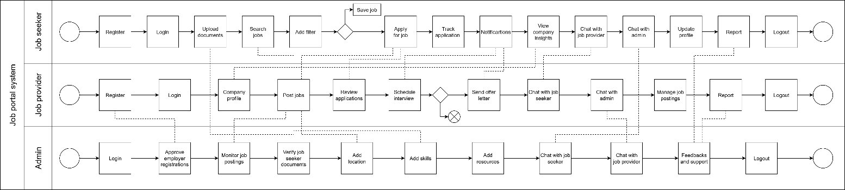

**3. Non-Functional Requirements**

Non-functional requirements define the qualities of a system. In other words, they’re not about what a system does but how it performs.

Some examples are

* Performance
* Security
* Compatibility
* Capacity
* Reliability
* Environment
* Usability
* Maintainability

**4. Technical Requirements**

The technical requirements of the Job Portal System define the hardware, software, and development tools necessary to build and operate the platform effectively. These requirements ensure that the system is developed using modern, secure, and scalable technologies, while maintaining compatibility with current industry standards.

**Hardware Requirements**

| **Component** | **Specification** |
| --- | --- |

|  |  |
| --- | --- |
| Processor | Intel Core i5 |

|  |  |
| --- | --- |
| RAM | 16 GB |

|  |  |
| --- | --- |
| Storage | 512 GB SSD |

|  |  |
| --- | --- |
| Internet | High-speed connection (min. 10 Mbps) |

|  |  |
| --- | --- |
| System Type | 64-bit Operating System, x64-based processor |

|  |  |
| --- | --- |
| Operating System | Windows 10 |

**Software Requirements**

| **Component** | **Specification** |
| --- | --- |

|  |  |
| --- | --- |
| Operating System | Windows 10 |

|  |  |
| --- | --- |
| Frontend | HTML5, CSS3, JavaScript, Bootstrap |

|  |  |
| --- | --- |
| Backend | ASP.NET / .NET Core |

|  |  |
| --- | --- |
| Database | Microsoft SQL Server |

**5. Conclusion**

A job portal conclusion should summarize its success in creating a user-friendly, efficient platform that connects job seekers and employers, saving time and expanding opportunities. It should highlight the system's ability to streamline the traditional recruitment process, mention the benefits of features like advanced matching and secure data handling, and acknowledge the ongoing potential for future enhancements, such as AI integration and improved user experience. The conclusion should also recognize the portal's significant role in the modern job market and its contribution to transforming employment into a smarter, more accessible process.